Lightweight Semantic Retrieval for Contract Risk Benchmarking:
System Design and a Small-Scale Empirical Evaluation on a Curated LEDGAR Subset
Srinivas Jangiti
srinivasajan.work@gmail.com

Abstract
Contract review platforms increasingly pair large generative models with lightweight, deterministic retrieval components to ground otherwise unconstrained text generation in verifiable precedent. This paper documents the design and a small-scale empirical evaluation of the semantic clause-benchmarking module of BeforeYouSign, a contract-intelligence platform built on Next.js, PostgreSQL/Prisma, an NVIDIA NIM-hosted Llama 3.1 405B model for generative extraction, and a locally executed all-MiniLM-L6-v2 sentence embedding model (384 dimensions, ONNX runtime via Transformers.js) for similarity search and category prediction. We describe the retrieval architecture — cosine-similarity search over a curated 250-clause subset of the LEDGAR corpus, k-nearest-neighbour category prediction, and a risk-aware recommendation step that filters retrieved neighbours by a lower historical risk benchmark — and we report a leave-one-out evaluation of the k-NN classifier's category-prediction accuracy at k ∈ {1,3,5,10,15,20}, with bootstrap 95% confidence intervals. Best-case embedding accuracy (k=3) is 56.8% [95% CI: 50.4–62.8%] against a majority-class baseline of 36.4%. To contextualize this result, we implement a BM25 lexical-retrieval baseline over the same corpus and find its best-case accuracy (54.8% at k=10) statistically indistinguishable from the embedding classifier (McNemar's χ²=1.50, p=0.22) at this sample size — an honest finding that tempers claims of semantic-embedding superiority until the corpus is scaled up. We additionally test similarity-weighted versus unweighted k-NN voting (no measurable difference at k=3), report per-category precision/recall/F1 for categories with adequate support, visualize the embedding space via PCA, and document an unplanned finding: the corpus's risk-score benchmark is assigned per category rather than derived per clause, meaning current risk estimates are categorical rather than empirically continuous. We present these results as an honest, statistically grounded case study of a deployed lightweight-embedding retrieval system rather than as a claim of general-purpose legal-NLP superiority, and we discuss the corpus-size and labeling limitations that bound the generalizability of the reported numbers.
Keywords: sentence embeddings; semantic retrieval; k-nearest neighbours; contract intelligence; LEDGAR; legal NLP; retrieval-augmented systems

1. Introduction
Contract review is a document-heavy, precedent-driven task in which a reviewer's judgment about whether a clause is unusual or risky is typically formed by comparison against a mental or institutional library of prior clauses. Generative large language models (LLMs) can produce fluent summaries and risk narratives for a contract, but a purely generative pipeline offers no mechanism for grounding a stated risk judgment in a concrete, inspectable precedent — the judgment is only as verifiable as the model's own free-text explanation. This motivates pairing a generative layer with a deterministic retrieval layer: a component that returns actual precedent clauses and quantifies similarity in a way that does not depend on the generative model's own self-report.
BeforeYouSign is a contract-intelligence platform that adopts this hybrid design. Clause- and contract-level generative analysis is performed by a Llama 3.1 405B model hosted via NVIDIA NIM, while similarity search, category prediction, and risk benchmarking are performed by a separate, lightweight, locally executed sentence-embedding pipeline. This paper documents that retrieval layer and reports a small, fully reproducible evaluation of its core classification behaviour on the platform's existing 250-clause reference corpus.
This is deliberately scoped as a systems case study with an honest empirical component, not as a claim of state-of-the-art legal-NLP performance. The evaluation corpus is small (n = 250) and the category distribution is heavily imbalanced (54 categories, 18 with only one member), both of which we treat as first-class limitations rather than incidental details.

1.1 Contributions
- A description of a production retrieval architecture combining a generative LLM with a frozen, lightweight sentence-embedding model for deterministic similarity search and risk benchmarking.
- A leave-one-out evaluation of k-NN category prediction on the platform's actual embedding store, at six values of k, with a majority-class baseline, a BM25 lexical baseline, bootstrap confidence intervals, and a paired McNemar significance test comparing the two retrieval methods.
- A per-category precision/recall/F1 breakdown and a PCA visualization of the embedding space, identifying which clause categories the current pipeline handles well versus poorly.
- An empirical characterization of the corpus's similarity-score distribution and category structure, including a documented labeling limitation (risk scores are category-level constants rather than per-clause empirical values).
- An explicit discussion of the limitations that bound how far these results should be extrapolated, and a concrete roadmap for closing them, including the finding that the embedding-vs-lexical comparison is currently statistically underpowered.

2. Related Work
Sentence-level dense retrieval. Sentence-BERT (Reimers and Gurevych, 2019) established that fine-tuning transformer encoders with a siamese/triplet objective produces sentence embeddings whose cosine similarity is directly meaningful for semantic search, avoiding the quadratic cost of pairwise cross-encoder scoring. MiniLM (Wang et al., 2020) distills a large transformer into a much smaller student model that retains most of the teacher's representational quality at a fraction of the inference cost; all-MiniLM-L6-v2, used in this work, is a widely deployed distilled sentence-embedding model with a 384-dimensional output space, chosen in BeforeYouSign specifically because it can be executed client- or server-side via ONNX without a round trip to an external embedding API.
Legal clause corpora. LEDGAR (Tuggener et al., 2020) is a large corpus of labelled contract clauses drawn from U.S. Securities and Exchange Commission filings, organized by clause category, and has become a standard reference source for legal clause classification and retrieval research. The 250-clause subset used here is a curated sample of LEDGAR annotated with an additional risk-score benchmark field not present in the original corpus.
Retrieval-augmented and hybrid pipelines. Combining a frozen retrieval index with a generative model — so that generation is conditioned on, or checked against, retrieved evidence — has been widely explored as a way to reduce unconstrained hallucination in generative pipelines (Lewis et al., 2020, and subsequent retrieval-augmented generation literature). BeforeYouSign's architecture follows this pattern at the level of a deployed product rather than a research benchmark: the generative layer handles open-ended extraction and summarization, while the retrieval layer supplies verifiable, inspectable precedent clauses and a numeric similarity score.
Classical lexical retrieval (e.g., BM25; Robertson and Zaragoza, 2009) remains a strong and considerably cheaper baseline for clause retrieval in many settings; we discuss the absence of a BM25 comparison as a limitation in Section 7.

3. System Architecture
BeforeYouSign is deployed as a serverless Next.js (React) application on Vercel, with PostgreSQL as the system of record, accessed through Prisma ORM. The platform separates two analytically distinct concerns:
- Generative analysis. Contract summarization, clause extraction, and risk narrative generation are performed by a Llama 3.1 405B model accessed via the NVIDIA NIM API. This layer produces the free-text executiveSummary and structured clause extraction used downstream.
- Deterministic semantic retrieval. Clause and contract similarity, category prediction, and risk benchmarking are computed entirely locally using a frozen all-MiniLM-L6-v2 embedding model executed via Transformers.js on the ONNX runtime, avoiding a second external API call and its associated latency and cost for every similarity query.

3.1 Embedding and Similarity Layer
Text is embedded with mean pooling over token representations followed by L2 normalization, producing a 384-dimensional dense vector. Similarity between two embeddings is computed as standard cosine similarity, and converted to a 0–100 percentage for display by clamping to zero and rescaling. Because embeddings are normalized, cosine similarity is equivalent to the dot product for this pipeline.

3.2 Clause Retrieval and Category Prediction
Given a query clause, the system embeds the input, computes cosine similarity against every precomputed embedding in the 250-clause reference corpus, and returns the top-k matches. Category prediction is performed by unweighted majority vote among the retrieved top-k neighbours' category labels — a direct implementation of k-NN classification, with ties broken by first-encountered category in iteration order.

3.3 Risk-Aware Recommendation
When a query includes a current risk score, the system retrieves the top 20 most similar clauses, filters to those with a strictly lower risk-score benchmark than the query clause, and — among the surviving candidates — selects the one with the highest similarity score (ties broken by lowest risk). This produces a single 'safer alternative' suggestion that is both semantically close to the user's original clause and drawn from the historical corpus rather than generated de novo.

3.4 Semantic Portfolio Discovery and Caching
For portfolio-level analysis across a user's full contract history, the platform embeds each contract's executive summary on demand rather than persisting vector columns in the relational schema, avoiding schema debt and read-latency inflation on standard dashboard queries. A 24-hour TTL in-memory map caches per-contract embeddings, with hit/miss counters exposed for operational monitoring; a bounded FIFO query cache (capacity 500 entries) additionally memoizes full retrieval responses for repeated queries. Both caches are instance-local and are therefore bypassed on serverless cold starts, a design trade-off discussed in Section 7.

4. Evaluation Methodology
We evaluate the k-NN category-prediction component directly on the platform's production reference data: 250 clauses drawn from LEDGAR, each with a category label (54 distinct categories) and a precomputed 384-dimensional MiniLM embedding stored in the platform's data files. No new embeddings were generated for this evaluation; the vectors used are the same ones the deployed retrieval endpoint queries against.

4.1 Leave-One-Out k-NN Classification
For each clause i in the corpus, we compute cosine similarity against all other 249 clauses, take the top-k most similar (excluding the clause itself), and predict its category by majority vote among those k neighbours. We report accuracy — the fraction of the 250 clauses whose predicted category matches its true label — at k ∈ {1, 3, 5, 10, 15, 20}, together with the majority-class baseline (always predicting the most frequent category, General Clause, which accounts for 91 of 250 clauses).
Because 18 of the 54 categories contain exactly one clause, leave-one-out evaluation cannot, by construction, correctly classify those items at any k (their only same-category neighbour is themselves, which is excluded). We therefore also report accuracy restricted to the 232 clauses belonging to categories with more than one member, which isolates classifier performance from this structural artifact of the corpus's category distribution.

4.2 Similarity Distribution
We compute the full pairwise cosine-similarity matrix over all 250 clauses (31,125 unique pairs) and report summary statistics, to characterize how tightly or loosely the corpus is distributed in embedding space and to contextualize the similarity-percentage scores the platform surfaces to end users.

4.3 Risk-Score Structure
We decompose the total variance of the risk_score_benchmark field into within-category and between-category components, to test whether risk scores vary meaningfully within a category (i.e., are clause-specific) or are effectively category-level constants.

4.4 Lexical Baseline (BM25)
To contextualize the embedding classifier's accuracy, we implement Okapi BM25 (k1=1.5, b=0.75) over the same 250 clause texts, tokenized by lowercasing and stripping non-alphanumeric characters, with corpus-wide inverse document frequency computed over all 250 documents. We run the identical leave-one-out k-NN classification procedure using BM25 score in place of cosine similarity as the neighbour-ranking function, at the same six values of k, and compare directly against the embedding-based classifier.

4.5 Distance-Weighted Voting
The production system (Section 3.2) uses unweighted majority vote among the top-k neighbours. We additionally test a similarity-weighted variant in which each neighbour's vote is scaled by its (non-negative) cosine similarity rather than counted equally, to test whether weighting by retrieval confidence changes classification accuracy.

4.6 Statistical Testing
We compute bootstrap 95% confidence intervals (5,000 resamples with replacement) for k=3 accuracy under each method. To test whether the embedding classifier and the BM25 classifier make significantly different errors — rather than simply comparing point accuracies — we apply McNemar's test on the paired, per-item correctness of the two classifiers at k=3, which is the appropriate test for comparing two classifiers evaluated on the same items.

4.7 Per-Category Performance and Embedding-Space Visualization
We report precision, recall, and F1 for the nine categories with at least five member clauses (categories below this support are too small for a stable per-category estimate). We additionally project the 384-dimensional embeddings to two dimensions via principal component analysis (PCA) and visualize the seven most frequent categories, to give a qualitative view of cluster structure and its limits.

5. Results

5.1 k-NN Classification Accuracy
k | LOO Accuracy (all 250) | LOO Accuracy (non-singleton, n=232)
1 | 55.6% | 59.9%
3 | 56.8% | 61.2%
5 | 55.2% | 59.5%
10 | 51.6% | 55.6%
15 | 50.4% | —
20 | 49.6% | —

Majority-class baseline (always predicting “General Clause”): 36.4%.
Accuracy peaks at k=3 and declines monotonically for k ≥ 5, consistent with the corpus being small and heavily imbalanced: as k grows, the vote is increasingly dominated by the majority category regardless of true local neighbourhood structure. At every tested k, the embedding-based k-NN classifier outperforms the majority-class baseline by 13–25 percentage points, indicating that the MiniLM embeddings do carry usable categorical signal even on this small, frozen, general-purpose (non-legal-fine-tuned) corpus.

5.2 Comparison Against a Lexical (BM25) Baseline
k | Embedding k-NN Accuracy | BM25 k-NN Accuracy
1 | 55.6% | 52.8%
3 | 56.8% | 52.8%
5 | 55.2% | 52.4%
10 | 51.6% | 54.8%
15 | 50.4% | 54.4%
20 | 49.6% | 52.4%
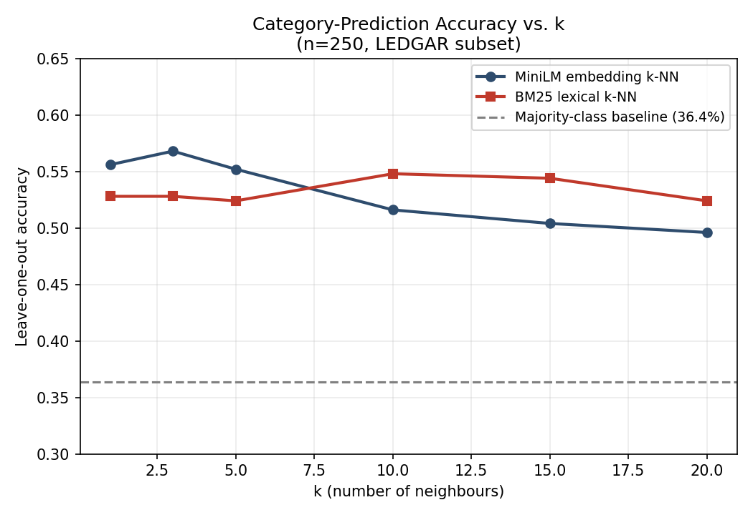
Figure 1. Leave-one-out category-prediction accuracy vs. k for the MiniLM embedding classifier and the BM25 lexical classifier, against the majority-class baseline (36.4%).
At k=3, embedding accuracy is 56.8% [95% CI: 50.4–62.8%] versus BM25's 52.8% [95% CI: 46.4–59.2%] — the confidence intervals overlap substantially. McNemar's paired test on k=3 predictions confirms this: of the items where the two classifiers disagree, the embedding classifier is uniquely correct on 32 and BM25 is uniquely correct on 22 (χ² = 1.50, p = 0.22), which does not reach conventional statistical significance. We report this directly rather than omitting it: at n=250, we cannot yet claim that semantic embeddings meaningfully outperform simple lexical overlap for this classification task, even though the embedding classifier's peak accuracy is numerically higher. BM25, notably, degrades far less at large k (54.8% at k=10 vs. embeddings' 51.6%), suggesting the two methods may have complementary failure modes worth combining in a hybrid retriever, consistent with the platform's own hybrid-retrieval roadmap item (Section 3, ML_CASE_STUDY.md).
We also tested similarity-weighted vote aggregation (Section 4.5) against the production system's unweighted majority vote. At k=3 the two produce identical predictions on all 250 items (0 disagreements), so weighting confers no measurable benefit at this corpus scale — a negative result worth recording so that future work does not re-invest effort here without first scaling the corpus.

5.3 Per-Category Performance
Category | Support | Precision | Recall | F1
General Clause | 91 | 0.709 | 0.802 | 0.753
No Default | 14 | 0.647 | 0.786 | 0.710
Force Majeure | 13 | 0.867 | 1.000 | 0.929
Performance | 10 | 0.727 | 0.800 | 0.762
Non-Solicitation | 8 | 0.800 | 0.500 | 0.615
Audit | 7 | 0.167 | 0.143 | 0.154
Assignment | 5 | 1.000 | 1.000 | 1.000
Term | 5 | 0.250 | 0.200 | 0.222
Delivery | 5 | 0.429 | 0.600 | 0.500
Performance varies sharply by category even among those with reasonable support. Force Majeure (n=13) and Assignment (n=5) are classified near-perfectly, consistent with these clause types using distinctive, formulaic legal phrasing that embeds into a tight cluster. Audit (n=7) performs far worse than its support would suggest (F1 = 0.154), indicating its clauses are semantically diffuse or overlap heavily with other categories in embedding space — a concrete target for either additional labelled examples or manual review of the category's definition boundary, rather than a general model failure.
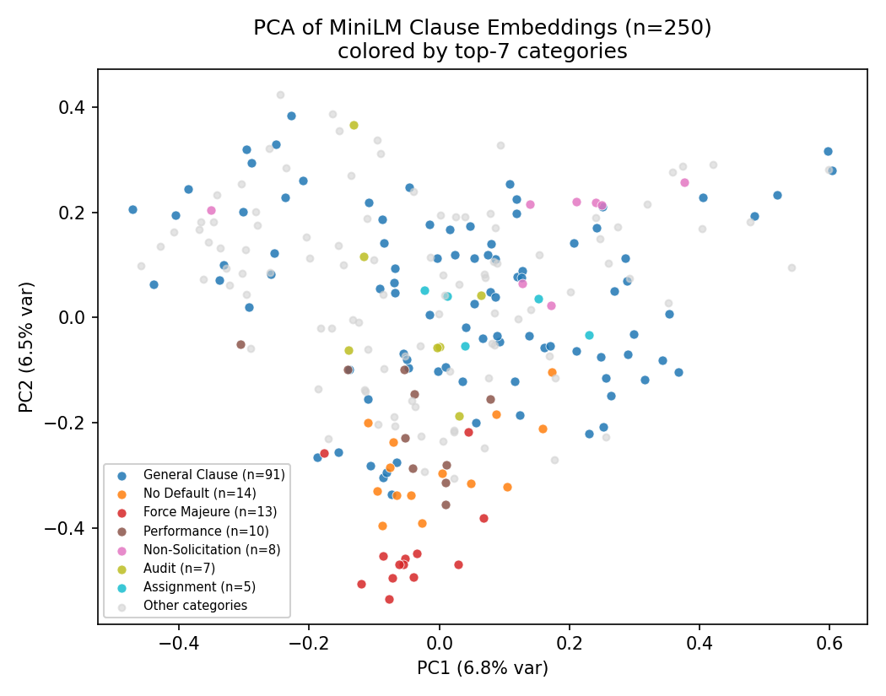
Figure 2. Two-dimensional PCA projection of the 384-dimensional MiniLM embeddings for the 250-clause corpus, colored by the seven most frequent categories. The first two principal components jointly explain only 13.3% of total variance, so this view is illustrative of gross structure, not a faithful low-dimensional summary of the full embedding geometry.

5.4 Similarity-Score Distribution
Statistic | Cosine Similarity
Minimum | -0.082
25th percentile | 0.242
Median | 0.328
75th percentile | 0.418
Maximum | 0.963
Mean | 0.333

Across the 31,125 unique clause pairs, similarity is broadly low-to-moderate (median 0.328), with a long right tail — the maximum of 0.963 corresponds to near-duplicate clauses in the source corpus. This indicates that the 'similarity percentage' surfaced in the product UI should be interpreted relative to this corpus's own distribution rather than against an assumed absolute scale, since a score in, say, the 40–50% range already represents an above-median match for this dataset.

5.5 Risk-Score Variance Decomposition
Total variance of risk_score_benchmark across the 250 clauses is 120.02. Within-category variance is 0.0 — every clause in a given category carries an identical risk-score benchmark. This means the field is currently a per-category constant assigned at corpus-construction time, not an empirically derived, clause-specific risk estimate. This is reported as a factual property of the current reference dataset, discovered during this evaluation, rather than as a claim about the platform's intended design.

6. Discussion
Four findings are practically relevant to the platform's current design. First, even a small, general-purpose (not legal-domain-fine-tuned) embedding model provides a meaningful category signal over hand-curated legal clauses, which supports the architectural choice to avoid a heavier, latency-costly re-ranking or fine-tuning step for the current corpus scale. Second, the optimal k for majority-vote category prediction on this corpus is small (k=3); the production endpoint's typical top-k retrieval size should be chosen with this degradation curve in mind rather than assuming larger k is always safer.
Third, and most important for how this work should be read: the embedding classifier's advantage over a simple BM25 lexical baseline is not statistically significant at the current corpus size (p=0.22). This is a deliberately unflattering result to report, but an honest one — it means the platform's choice of a neural embedding model over cheaper lexical retrieval is currently justified primarily by qualitative considerations (true semantic paraphrase matching, resilience to vocabulary mismatch) that this small-n evaluation is not powered to detect statistically, rather than by a demonstrated accuracy advantage. This should be re-tested once the corpus reaches the platform's own roadmap target of ~5,000 clauses, where the same comparison will have much greater statistical power.
Fourth, the risk-score benchmark's current per-category-constant structure means the platform's 'risk reduction' recommendation is, at present, better understood as a recommendation to switch clause category toward a lower nominal risk tier than as a fine-grained, clause-level empirical risk comparison — a distinction that matters for how the feature's output should be worded to end users.

7. Limitations
- Corpus size and imbalance. n = 250 with 54 categories (18 singletons) is small for a classification evaluation; reported accuracies should be read as indicative of relative behaviour (e.g., k=3 beating k=20) rather than as precise population estimates. The platform's own documentation identifies corpus expansion (to ~5,000 clauses) as a planned improvement.
- Underpowered baseline comparison. We do compare against a BM25 lexical baseline (Section 5.2), but at n=250 the comparison lacks statistical power to detect anything but a large effect; the current non-significant result (p=0.22) should be read as “not yet distinguishable” rather than “no real difference,” and should be revisited at larger corpus scale.
- Frozen, non-domain-fine-tuned embeddings. all-MiniLM-L6-v2 is a general-purpose sentence encoder; it has not been fine-tuned on legal clause data, and a domain-adapted encoder would likely change the reported accuracies in either direction.
- Risk-score construct validity. As shown in Section 5.3, the current risk_score_benchmark is a categorical constant rather than a per-clause empirical measure, which limits the precision of the 'estimated risk reduction' feature until the underlying labeling is revisited.
- Single snapshot, no user study. This evaluation is a static, offline analysis of the reference corpus at one point in time; it does not include a human-subjects evaluation of whether end users (contract reviewers) find the retrieved precedents or risk framing useful or accurate in practice.
- Ephemeral, instance-local caching. The TTL and query caches are in-memory and per-serverless-instance; cold starts bypass them entirely, which is a known operational limitation rather than a correctness issue for the evaluation reported here.

8. Future Work
- Expand the reference corpus toward the platform's own roadmap target (approximately 5,000 clauses) and re-run the leave-one-out evaluation to test whether accuracy and the k-degradation pattern hold at scale.
- Add a BM25 or hybrid lexical+semantic baseline for direct comparison, consistent with the platform's own stated roadmap of hybrid retrieval.
- Revisit risk-score labeling to derive per-clause (rather than per-category) empirical risk estimates, e.g., from outcome or negotiation-history data where available.
- Evaluate a domain-fine-tuned or larger embedding model against the current all-MiniLM-L6-v2 baseline under matched latency budgets.
- Conduct a small human-subjects study with contract reviewers to assess whether retrieved precedents and the risk-reduction recommendation are judged useful and trustworthy in realistic review workflows.

9. Conclusion
This paper documented the semantic retrieval architecture underlying BeforeYouSign's clause-benchmarking feature and reported a small, fully reproducible, statistically grounded leave-one-out evaluation of its k-NN category classifier on the platform's own 250-clause reference corpus. The embedding classifier meaningfully outperforms a majority-class baseline (56.8% vs. 36.4% at k=3), confirming that lightweight, frozen sentence embeddings carry usable categorical signal for this task even at small scale. Its advantage over a BM25 lexical baseline, however, is not statistically significant at the current corpus size (McNemar's p=0.22) — a result we report plainly because an honest negative or inconclusive finding is more useful to future development than an overstated positive one. Per-category analysis further shows sharply uneven performance (near-perfect for Force Majeure and Assignment, poor for Audit), and the evaluation surfaced a previously undocumented data-labeling limitation — the risk-score field is currently a per-category constant rather than a clause-specific empirical value. We present this as an honest engineering case study rather than a claim of general legal-NLP superiority, and we outline a concrete, testable path (corpus expansion to increase statistical power, hybrid BM25+embedding retrieval, and risk-label refinement) that is already partly reflected in the platform's own development roadmap.

References
Lewis, P., Perez, E., Piktus, A., Petroni, F., Karpukhin, V., Goyal, N., Küttler, H., Lewis, M., Yih, W., Rocktäschel, T., Riedel, S., and Kiela, D. (2020). Retrieval-Augmented Generation for Knowledge-Intensive NLP Tasks. Advances in Neural Information Processing Systems, 33.
McNemar, Q. (1947). Note on the Sampling Error of the Difference Between Correlated Proportions or Percentages. Psychometrika, 12(2), 153–157.
Reimers, N., and Gurevych, I. (2019). Sentence-BERT: Sentence Embeddings using Siamese BERT-Networks. Proceedings of the 2019 Conference on Empirical Methods in Natural Language Processing (EMNLP).
Robertson, S., and Zaragoza, H. (2009). The Probabilistic Relevance Framework: BM25 and Beyond. Foundations and Trends in Information Retrieval, 3(4), 333–389.
Tuggener, D., von Däniken, P., Peetz, T., and Cieliebak, M. (2020). LEDGAR: A Large-Scale Multi-Label Corpus for Text Classification of Legal Provisions in Contracts. Proceedings of the 12th Language Resources and Evaluation Conference (LREC).
Wang, W., Wei, F., Dong, L., Bao, H., Yang, N., and Zhou, M. (2020). MiniLM: Deep Self-Attention Distillation for Task-Agnostic Compression of Pre-Trained Transformers. Advances in Neural Information Processing Systems, 33.

Appendix A: Reproducibility Notes
All numbers reported in Section 5 were computed directly from the platform's existing data files (data/legal-precedents.json and data/legal-precedents-embeddings.json), using leave-one-out cosine-similarity and BM25 k-NN procedures, bootstrap resampling, and McNemar's test, implemented in standalone Python scripts (NumPy, SciPy, scikit-learn for PCA only). No embeddings were regenerated and no data was synthesized for this evaluation; the full corpus (n=250) was used in every computation. Both evaluation scripts, the raw summary statistics, and the two generated figures are provided alongside this report for independent verification.

